9. ročník – Kontrolní práce L1 Jméno:

**A. Poslech. Doplň chybějící slovo/ slova .** 

1. Sarah saw a ________________________ .

2. It was beside a _________________________ .

3. At first, Sarah _________________________ open it.

4. The ring had three red _________________________ .

5. The centre of the ring was _______________________________ .

6. They put it into a ______________________________ .

**B. Poslech. O kterých kalhotách mluví?** 

modré modré červené modré

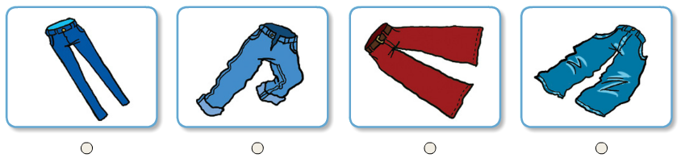

**C. Poslech. Doplň *pouze jedním* slovem.** 

1. What clothes did Mandy use to wear? ______________

2. What shoes didn´t Joseph use to wear? _______________

3. What kind of clothes did Sheila use to wear? _______________

4. What kind of jumpers didn´t Edward use to wear? _______________

**D. Přečti si a přiřaď.**

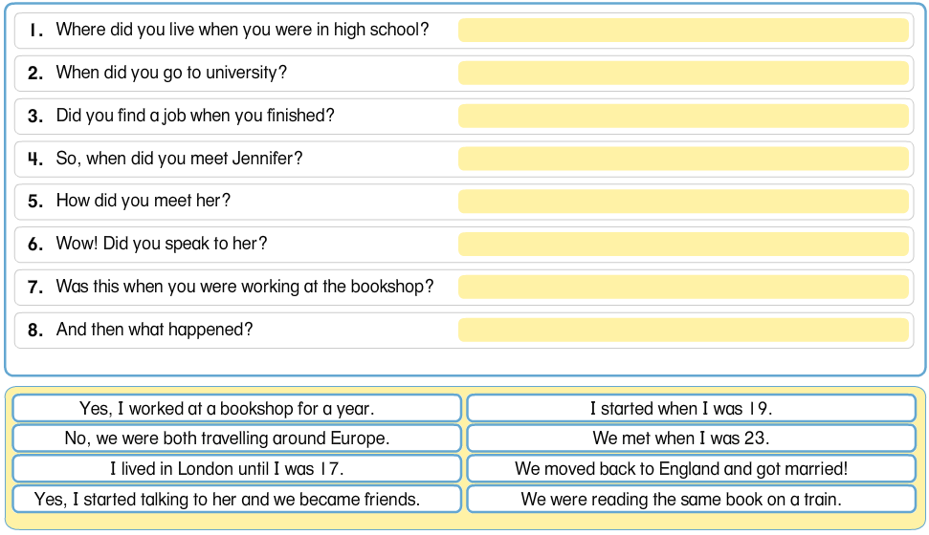

**H**

**G**

**F**

**E**

**D**

**C**

**B**

**A**

**E. Doplň přídavné jméno.**

1.These shoes are too small. they aren´t _________ enough.

2.This dress is too short! It isn´t _________ enough.

3. His T-shirt is too tight. It isn´t __________ enough.

4. That coat is too expensive. It isn´t __________ enough.

5. Those jeans are too baggy they aren´t ___________ enough.

**F. Čtení – porozumění – doplň jedním slovem**

Pasha’s Fashion Blog

I started my fashion blog when I was studying Art and Design at high school. I used to buy lots of magazines for people my age, but I didn’t like the style of any of the clothes in these magazines. Most of them were not interesting enough – they were just too boring. I was writing articles about this on my blog when a fashion designer in London contacted me. Now I work with him to design cool clothes that teenagers actually want to wear!

1. Pasha´s blog is about _________________ .

2. Pasha used to buy many __________________ .

3. He didn´t like the style of the __________________ in them.

4. He said they weren´t interesting ________________ .

5. He thought they were too _______________ .

6. Now Pasha works with a famous fashion _______________ .

9. ročník – Kontrolní práce L1 Jméno:

**G. Přečti si a oprav 6 chyb. Chybu podtrhni a na nový řádek napiš správně.**

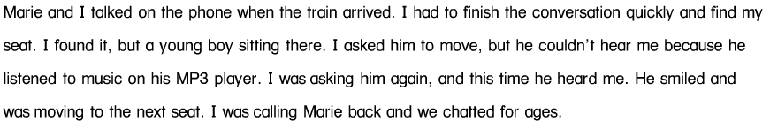

1. _________________________________________

2. _________________________________________

3. _________________________________________

4. _________________________________________

5. _________________________________________

6. _________________________________________

**H. Doplň. Vybírej z nabídky pod rozhovorem.**

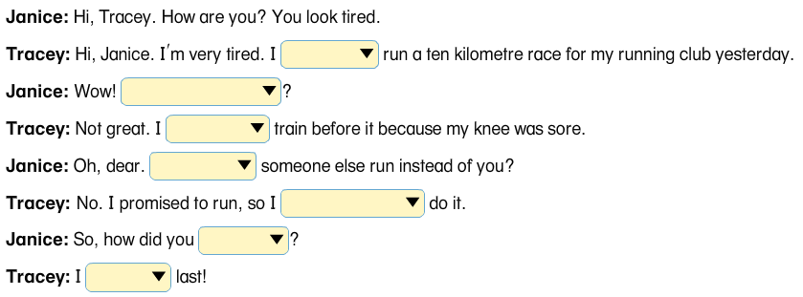

have to/had to/could /couldn´t /how did you go/ how did it go/go on/ get on/ hadn´t / couldn´t /had to / didn´t have to / came / got